Copy by value vs copy by reference

Copy by Value:
copy by value is method of copying data of a variable into another variable. IT is very useful and easy way to copy value of any variable of primitive datatype. But like every coin has two sides, when it comes to copy data of non-primitive object; it becomes a time consuming and memory vesting process.

1) Copy by value for primitive data:

Copy by value for primitive data works like this.:
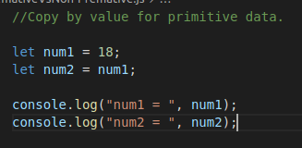

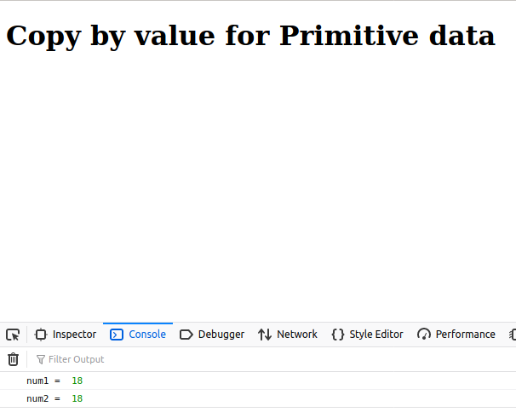

2) Copy by value for non-primitive data:

There are three ways to perform copy by values on composite data types. Those are as follows.:
1) Using the JSON.stringify() and JSON.parse() methods
2) Using the Object.assign() method
3) Using the spread (…) operator

Here we will see how how does JSON.stringify() and JSON.parse() works.

The JSON object is available in all modern browsers those has two useful methods to deal with JSON-formatted content: parse and stringify. JSON.parse(). It takes a JSON string and transforms it into a JavaScript object. JSON.stringify() takes a JavaScript object and transforms it into a JSON string. It works as follows.
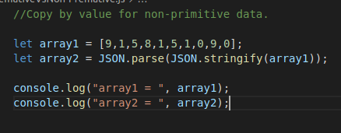

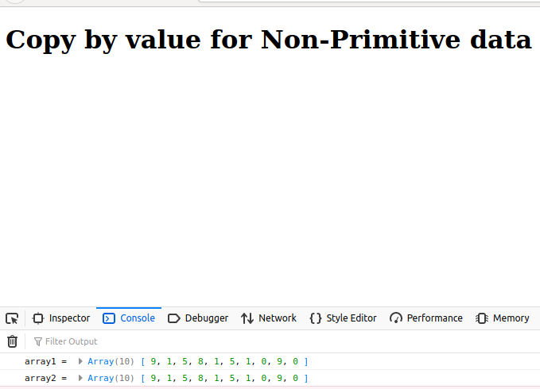

Copy by reference:
copy by reference is better option to copy non-primitive data as it works on location of data instead of working on exact data. Hence it is usually used in copying composite data instead of primitive data.

Copy by reference for non-primitive data:
Copy by reference is usually used for composite data like arrays, object,list etc.. In this method if content of first array has to copy into second array then instead of copying each element of the first array into second array it allots access of location of first array to the second array too. So it reduces both time and space complexity. Actually it works like this.:
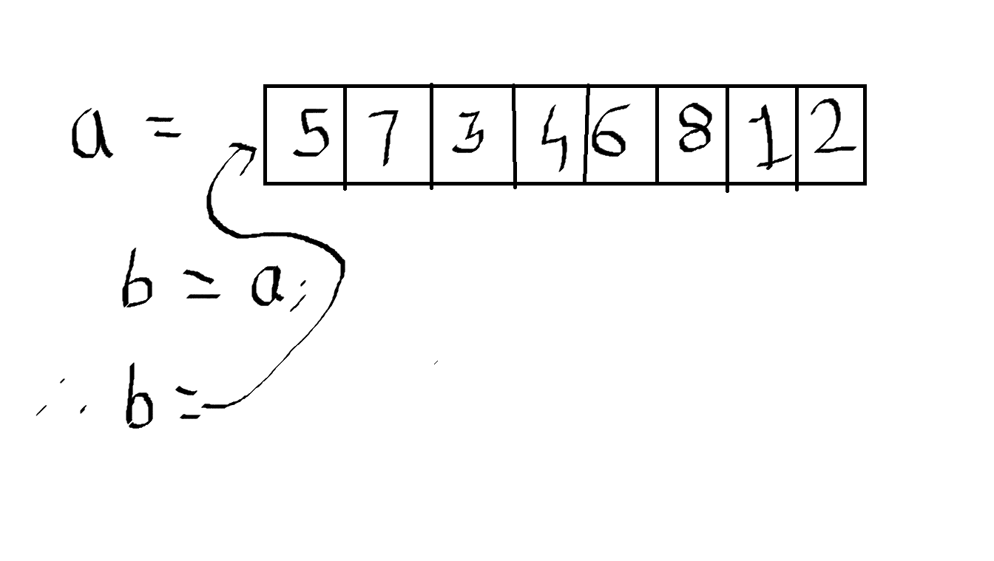
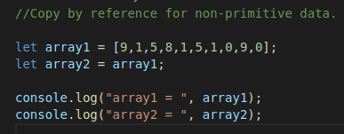

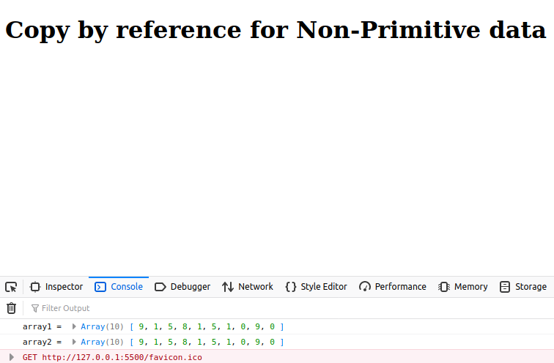
When we talk about about copy by reference in non-primitive data; when we make change to any one array, the another array also get changed automatically because both the arrays contains same reference address. They point to same collection of data. Eg:

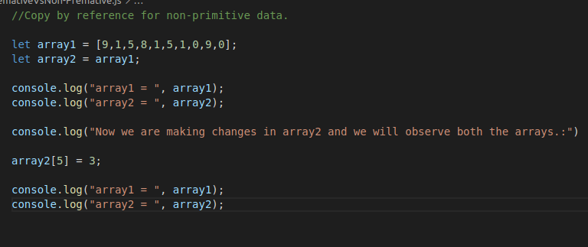
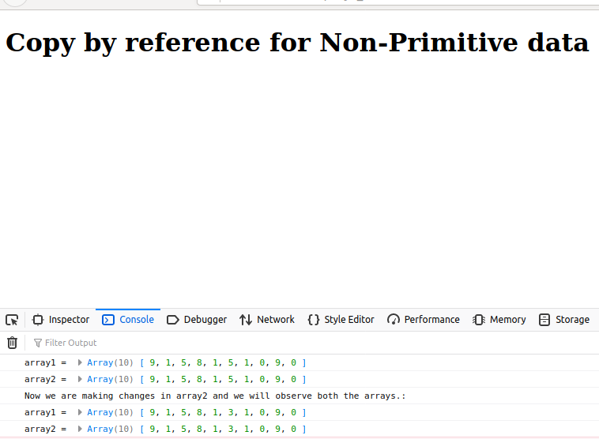

https://yash-khankhoje.medium.com/copy-by-value-vs-copy-by-reference-55820a444bc6

